**Aim:** Plotting of various activation functions

1. y={1 x<10 0   else

**Program:**

import matplotlib.pyplot as plt

x=[num for num in range(0,20)]

y=[]

for i in x:

if i>=10:

y.append(1)

else:

y.append(0)

plt.plot(x,y)

plt.xlabel("x axis")

plt.ylabel("y axis")

plt.title("y=1 if x>=10 else y=0")

plt.show()

**Output:**

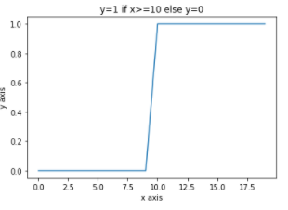

**2. y=eax for different values of a.**

**Program:**

import numpy as np

import matplotlib.pyplot as plt

num=[num for num in range(0,10)]

a=2 #constant value

x=np.array(num)*2

y=np.exp(x)

plt.plot(x,y)

plt.xlabel("x axis")

plt.ylabel("y axis")

plt.title("y=e**ax")

plt.show()

**Output:**

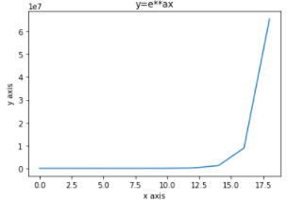

3. y=7x2+3x+10 for 2x5

Program:

import matplotlib.pyplot as plt

x=[x for x in range(2,6)]

y=[]

for i in x:

y.append(7*pow(i,2)+3*i+10)

plt.plot(x,y)

plt.xlabel('x axis')

plt.ylabel('y axis')

plt.title('y=7x^2+3x+10')

plt.show()

**Output:**

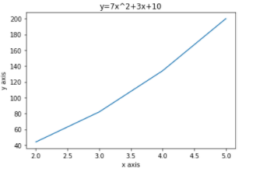

**4. y=11+e-x**

**Program:** import matplotlib.pyplot as plt  
import numpy as np  
x=[x for x in range(0,20)]  
p=np.array(x)  
p=1+np.exp(-p)  
y=1/p  
plt.plot(x,y)  
plt.xlabel('x axis')  
plt.ylabel('y axis')  
plt.show()

**Output:**

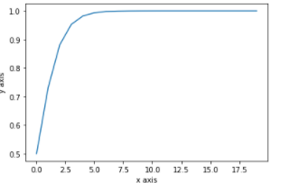

**5. y=1-e-ax1+e-axfor different values of a.**

**Program:**

import matplotlib.pyplot as plt

import numpy as np

num=[num for num in range(0,21)]

num=np.array(num)

a=2

p=1-np.exp(-num*a)

q=1+np.exp(-num*a)

y=p/q

plt.plot(num,y)

plt.xlabel('x axis')

plt.ylabel('y axis')

plt.show()

**Output:**

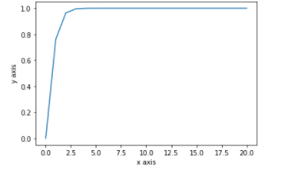

**6. y=tan hx**

**Program:**

import numpy as np

import matplotlib.pyplot as plt

in_array = np.linspace(0, np.pi, 12)

h=2

out_array =h*np.tan(in_array)

print("in_array : ", in_array)

print("\nout_array : ",out_array)

# red for numpy.tan()

plt.plot(in_array, out_array, color='red', marker="o")

plt.title("numpy.tan()")

plt.xlabel("X")

plt.ylabel("Y")

plt.show()

Output:

